import boto3

import botocore

config = botocore.config.Config(

    read_timeout=900,

    connect_timeout=900,

    retries={"max_attempts": 0}

)

session = boto3.Session(profile_name='497021971364_mnd-l3-support-role')*#, region_name='us-west-2')*

print(session.region_name)

proxy_definitions = {

    'http': 'http_proxy=http://PITC-Zscaler-Americas-Alpharetta3PR.proxy.corporate.ge.com:80',

    'https': 'https_proxy=http://PITC-Zscaler-Americas-Alpharetta3PR.proxy.corporate.ge.com:80',

    'no_proxy': '.ge.com'

}

s3 = session.client('s3', verify=False)

response = s3.list_buckets()['Buckets']

for bucket in response:

    print('Bucket name: {}, Created on: {}'.format(bucket['Name'], bucket['CreationDate']))

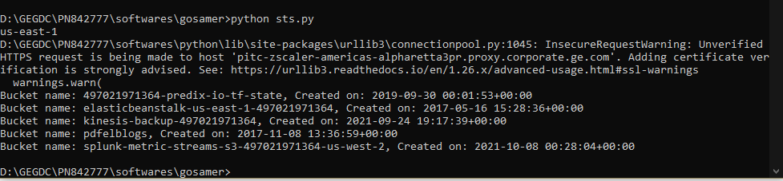

import boto3

import botocore

config = botocore.config.Config(

    read_timeout=900,

    connect_timeout=900,

    retries={"max_attempts": 0}

)

session = boto3.Session(profile_name='497021971364_mnd-l3-support-role')*#, region_name='us-west-2')*

print(session.region_name)

proxy_definitions = {

    'http': 'http_proxy=http://PITC-Zscaler-Americas-Alpharetta3PR.proxy.corporate.ge.com:80',

    'https': 'https_proxy=http://PITC-Zscaler-Americas-Alpharetta3PR.proxy.corporate.ge.com:80',

    'no_proxy': '.ge.com'

}

s3 = session.client('s3', verify=False)

response = s3.list_buckets()['Buckets']

for bucket in response:

        print('Bucket name: {},'.format(bucket['Name']))

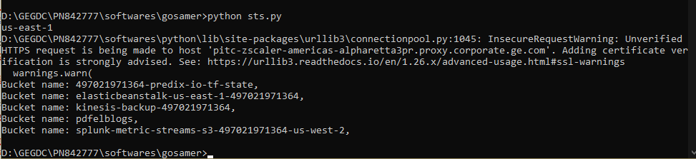

import boto3

session = boto3.Session(profile_name='011821064023_mnd-l3-support-role')*#, region_name='us-west-2')*

print(session.region_name)

proxy_definitions = {

    'http': 'http_proxy=http://PITC-Zscaler-Americas-Alpharetta3PR.proxy.corporate.ge.com:80',

    'https': 'https_proxy=http://PITC-Zscaler-Americas-Alpharetta3PR.proxy.corporate.ge.com:80',

    'no_proxy': '.ge.com'

}

*#s3 = session.resource('s3', verify=False)*

*#ge-power-arf-shim-stage-us-west-2-replication*

s3 = session.resource('s3', verify = False)

bytes = sum([object.size for object in s3.Bucket('ge-power-arf-shim-stage-us-west-2').objects.all()])

print(f'total bucket size: {bytes//1000/1024/1024} GB')

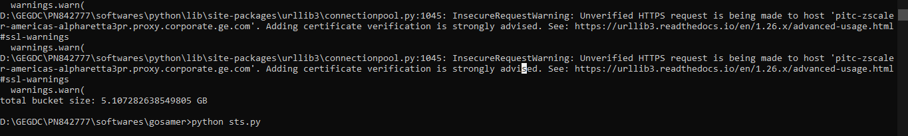

*# Module used in python for boto3*

import boto3

import json

*#creating a session of aws login using profile from aws_crediantials ENV*

session = boto3.Session(profile_name='011821064023_mnd-l3-support-role')

*#testing the login by getting region name of the above profile*

print(session.region_name)

*#defined proxy for the flow of data between clients*

proxy_definitions = {

    'http': 'http_proxy=http://PITC-Zscaler-Americas-Alpharetta3PR.proxy.corporate.ge.com:80',

    'https': 'https_proxy=http://PITC-Zscaler-Americas-Alpharetta3PR.proxy.corporate.ge.com:80',

    'no_proxy': '.ge.com'

}

*#defining the services we want using sessions here ver defined s3 session*

*#s3 = session.resource('s3', verify = False)*

s3 = session.client('s3', verify=False)

result = s3.get_bucket_lifecycle (Bucket='ge-power-arf-shim-stage-us-west-2-replication')

*#print(result)*

json_formatted_str = json.dumps(result)

print(json_formatted_str)

